## Summer Internship Report on

### “Web Development (ReactJS)”

*By*

**MALEK TASKIN HASANALI**

**(2007060107503)**

*Under the guidance of*

**Prof. Anali Shah**

A Project Report Submitted to

Gujarat Technological University

In Partial Fulfillment of the Requirements for

The degree of Bachelor of Engineering

In**COMPUTER ENGINNERING**

October - 2022

**

**SHREE SWAMI ATMANAND SARASWATI INSTITUTE OF TECHNOLGY, SURAT**

# CERTIFICATE

This is to certify that project work embodied in this report entitled “***WEB DEVELOPMENT (REACTJS)*”** was carried out by **Miss. MALEK TASKIN HASANALI** at **LEAF DRIVE IT SOLUTIONS** for partial fulfillment of B.E.degree to be awarded by Gujarat Technological University. This project work has been carried outunder my supervision and is to the satisfaction of department. The student’s work has been published/accepted for publication.

Date:

Place:

|  |  |  |
| --- | --- | --- |
| Prof. Anali Shah | Prof. Vrutti Shah | |
| **Signature and Name of Guide** | **Signature and Name of Head of Dept.** | |
|  |
|  |
| Prof. Jignesh G. Vaghasia  **Name of Principal**  **Seal of Institute** | |

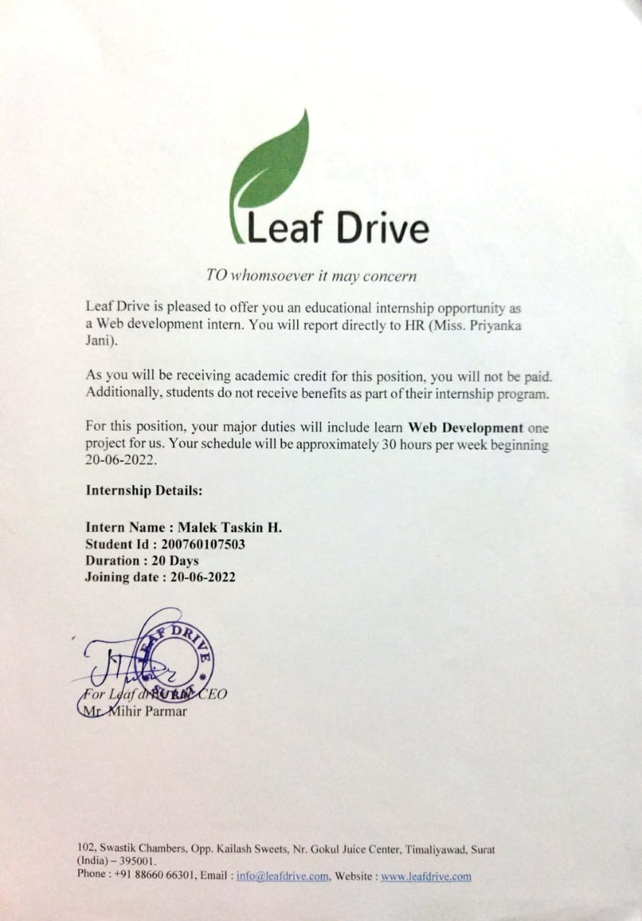

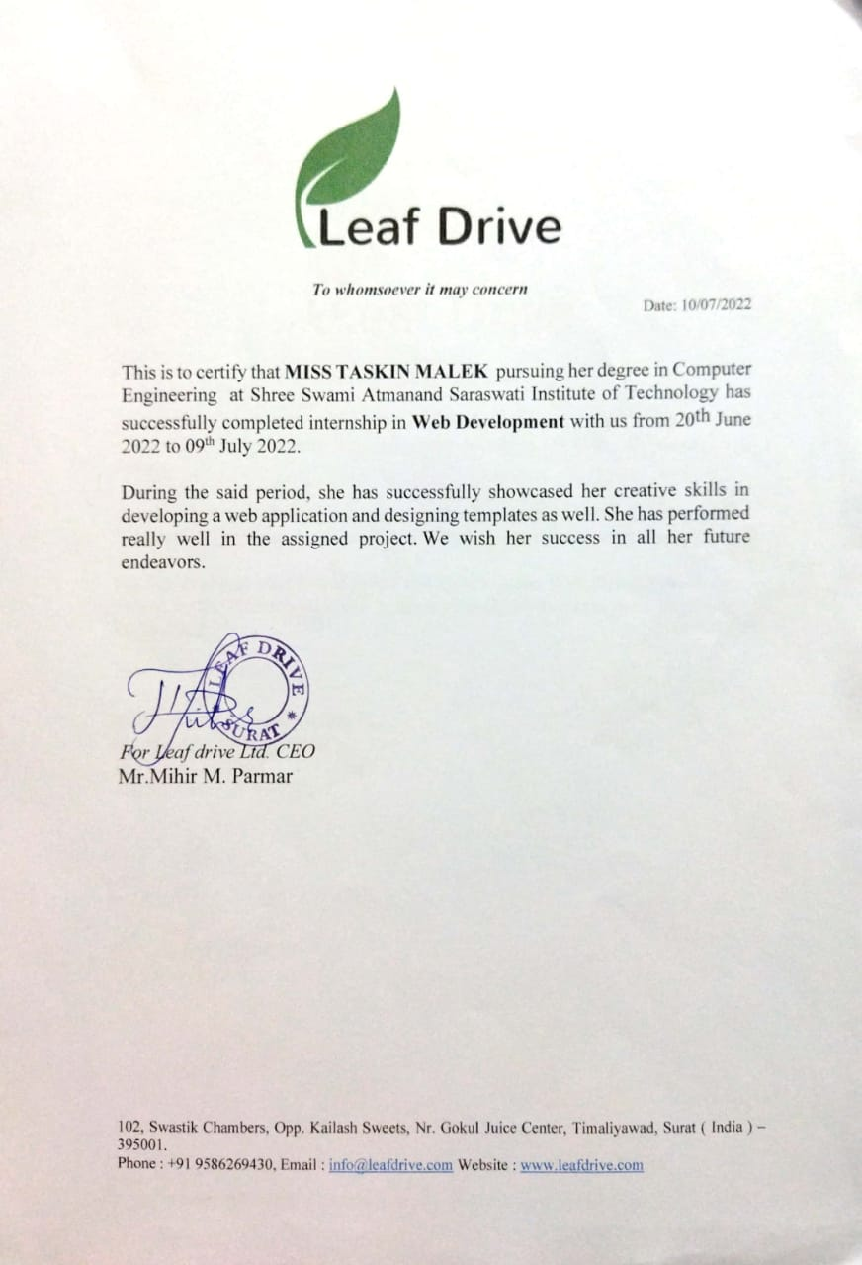

### SELF – DECLARATION

I hereby certify that I am the sole author of this report and that neither any part of this work nor the whole of the work has been submitted for a degree to any other University or Institution. I certify that, to the best of my knowledge, my work does not infringe upon anyone’s copyright nor violate any proprietary rights and that any ideas, techniques, quotations, or any other material from the work of other people included in my report, published or otherwise, are fully acknowledged in accordance with the standard referencing practices. Furthermore, to the extent that I have included copyrighted material that surpasses the bounds of fair dealing within the meaning of the Indian Copyright Act, I certify that I have obtained a written permission from the copyright owner(s) to include such material(s) in my work and have included copies of such copyright clearances to my appendix. I declare that this is a true copy of my report, including any final revisions, as approved by my supervisor.

Date:

Place:

***Malek Taskin Hasanali***

**Acknowledgement**

The success of any task relies on the efforts made by person but it cannot be achieved without cooperation of other persons which are being helpful. So, we would like to thank **SHREE SWAMI ATMANAND SARASWATI INSTITUTE OF TECHNOLOGY** and **LEAF DRIVE IT SOLUTIONS** for giving us the opportunity of doing this Summer Internship.

The entire session of our internship completion was a great experience providing us with the insight & invocation into learning various software engineering concepts & benefits of team work. We would like to take this opportunity to express our sincere thanks to all those people without whose support and co-operation, it would have been difficult to complete this project.

Primarily, we are very much thankful to our Internship Mentor **Mr. Mihir Parmar** and PMMS Internship Faculty guide **Prof. Anali Shah** for their leading guidance and sincere efforts throughout project work. They took deep interest in simplifying the difficulties. Also, they have been consistent source of inspiration for us.

We also express thanks to **Prof. Vidhi Patel** class coordinator for her personal involvement, constructive suggestion and thoughtful idea for betterment ofthe project.

We are grateful to our **H.O.D. Prof. Vrutti Shah** and our beloved Principal **Prof. Jignesh Vaghasiya** for providing us deep knowledge and all necessary resources.

We are also thankful to our **Friends** and **Non-teaching Staff** for their valuable time & help for completion project.

Once again, we are grateful to all those without whom this this work would not have been successful.

**MALEK TASKIN HASANALI**

**TABLE OF CONTENTS**

TITLE PAGE I

CERTIFICATE II

SELF DECLARATION V

ACKNOWLEDGMENT VI

TABLE OF CONTENT VII

LIST OF FIGURES IX

LIST OF TABLES X

ABSTRACT XI

CHAPTER 1: INTRODUCTION 1

* 1. INTRODUCTION TO REACT JS 1
  2. COMMON USE OF REACT JS 1
  3. FEATURES OF REACT JS 1
  4. TOOLS AND TECHNOLOGIES 2

CHAPTER 2: COMPANY DETAILS 3

* 1. DETAILS AND VISION MISSION 3
  2. SERVICES 3

CHAPTER 3: TIMELINE OF TASK AND TOPICS 4

CHAPTER 4: WORKING WITH REACTJS 5

* 1. WEB APPLICATION FOR LIST OF NETFLIX SERIES 5
  2. WEB APPLICATION FOR DIGITAL CLOCK 6
  3. WEB APPLICATION FOR TO DO LIST 7

CHAPTER 5: WORKING WITH REACT PROJECT 8

* 1. CREATED A TOPBAR COMPONENT 8
  2. CREATED A SIDEBAR COMPONENT 8
  3. CREATED A SHARE COMPONENT 9
  4. CREATED A POST COMPONENT 9
  5. CREATED A RIGHTBAR COMPONENT 10
  6. CREATED A PROFILE PAGE 10
  7. CREATED A LOGIN PAGE 11
  8. CREATED A REGISTRATION PAGE 11

CHAPTER 6: CONCLUSION 12

REFERENCES 13

**LIST OF FIGURES**

FIG 4.1 NETFLIX WEB APP…………………………………………………………………5

FIG 4.2 NETFLIX PAGE ………………………………………………………………………5

FIG 4.3 DIGITAL CLOCK…………………………...…..………….………………………..6

FIG 4.4 TO DO LIST …………………….…..………….………....….……………..……….7

FIG 5.1 TOPBAR COMPONENT……………...……………………….…………………….8

FIG 5.2 SIDEBAR COMPONENT….......…....………………….……….……….…………..8

FIG 5.3 SHARE COMPONENT……..……..………...……….………….…………………...9

FIG 5.4 POST COMPONENT…………………………………………….…………………..9

FIG 5.5 RIGHTBAR COMPONENT………………………………………………………..10

FIG 5.6 PROFILE PAGE ……………………………………………………………………10

FIG 5.7 LOGIN PAGE ………………………………………………………………………11

FIG 5.8 REGISTRATION PAGE …………………………………………………………………11

**LIST OF TABLES**

TABLE 1: TIMELINE OF TASK AND TOPIC 4

### ABSTRACT ON WEB DEVELOPMENT(REACTJS)

*Submitted By*

**MALEK TASKIN HASANALI**

*Supervised By*

**Mr. Mihir Parmar**

**Leaf Drive IT Solutions,**

**SURAT**

**ABSTRACT**

*React is a JavaScript library for building user interfaces. It is used to build single-page applications which also allows to create reusable UI components.* *React is a declarative, efficient, and flexible JavaScript library for building user interfaces. It is a library developed by Facebook to solve some problems that we were facing earlier.It is an open-source, component-based front end library responsible only for the view layer of the application and is maintained by Facebook.* *React uses a declarative paradigm that makes it easier to reason about your application and aims to be both efficient and flexible and designs simple views for each state in the application, and will efficiently update and render just the right component when data changes.*

## CHAPTER 1: INTRODUCTION

#### INTRODUCTION TO REACTJS

ReactJS is a declarative, efficient, and flexible JavaScript library for building reusable UI components. It is an open-source, component-based frontend library responsible only for the view layer of the application. A ReactJS application is made up of multiple components, each component responsible for outputting a small, reusable piece of HTML code.

The components are the heart of all React applications. These Components can be nested with other components to allow complex applications to be built of simple building blocks. ReactJS uses virtual DOM based mechanism to fill data in HTML DOM. The virtual DOM works fast as it only changes individual DOM elements instead of reloading complete DOM every time.

#### COMMON USE OF REACTJS

ReactJS can be used for:

1. Creation of Dynamic web applications is easier
2. It increases productivity and also helps in maintenance
3. Ensures faster rendering of Virtual DOM
4. It ensures to have a stable code
5. Flux and Redux architecture
6. It has SEO Friendly features

#### FEATURES OF REACTJS

There are many features in ReactJS, some of which are discussed below:

1. JSX (JavaScript Syntax Extension)
2. Virtual DOM
3. One-way data binding
4. Performance
5. Extensions
6. Conditional statements
7. Components
8. Portable
9. Simplicity

#### TOOLS AND TECHNOLOGIES

* + - **Technology:** ReactJS for web development
    - **Tools**: Visual Studio Code

## CHAPTER 2: COMPANY DETAILS

## 2.1 Details and Vision Mission:

## Name: Leaf Drive IT Solutions

## Location: SURAT

## Email: [LeafdriveITsolution@gmail.com](mailto:LeafdriveITsolution@gmail.com)

## Vision:

## We are a creative digital agency based in India. Our aim is provide best services and knowledge to every client and employee with out best guidance.

## Mission:

## To provide outstanding quality and variety of services in the region.

## 2.2 Services:

## Mobile Application Development

## Web Design and Development

## PHP Development

## Flutter Development

## Python

## CHAPTER 3: TIMELINE OF TASK AND TOPICS

Table 1: Timeline of Task and Topics

|  |  |  |
| --- | --- | --- |
| Sr No | Date | Topics and Task |
| 1 | 20 June 2022 | HTML tags  HTML forms  Concepts of HTML |
| 2 | 21 June 2022 | Different ways to use CSS  CSS selectors  Other concepts of CSS |
| 3 | 22 June 2022 | Embedding JS with HTML files  OOP’s Concepts  Variable declaration and variable scope  Operators and other concepts |
| 4 | 23 June 2022 | JS Loops  Event Handling and Popup boxes  Introduction to ReactJS |
| 5 | 24 June 2022 | History of ReactJS  Installing VS Code  Add different Extensions in VS Code |
| 6 | 27 June 2022 | Installing NodeJS  Install React from terminal  Information of different files of ReactJS app. |
| 7 | 28 June 2022 | Basic hello world program  Virtual DOM and Real DOM, render method |
| 8 | 29 June 2022 | JavaScript extension in JSX  ES6 Template literals |
| 9 | 30 June 2022 | Designed Detail Courses Component.  Designed Accordion Section.  Use google fonts in ReactJS. |
| 10 | 01 July 2022 | CSS styling and importing CSS Files, Internal CSS and inline CSS styling. |
| 11 | 04 July 2022 | Props in ReactJS, map method, Fat arrow function  Challenge for list of Netflix Series. |
| 12 | 05 July 2022 | Condition rendering, implement slot machine,  Hooks in ReactJS, useState, useEffect Concept |
| 13 | 06 July 2022 | Complete challenge for digital clock,  Handling events, forms in ReactJS  Implement To Do List |
| 14 | 07 July 2022 | Started work on web application REACHME design homepage with components topbar, sidebar, share |
| 15 | 08 July 2022 | Implement other components post, profile, login and registration page, friends list using dummy data. |

## CHAPTER 4: WORKING WITH REACTJS

#### Web application for list of Netflix Series:

* + - This challenge is to create web app from the Scratch, display top 5 Netflix series with the use of props, map method, Fit arrow function.
    - On clicking watch now button the page is directed to Netflix page

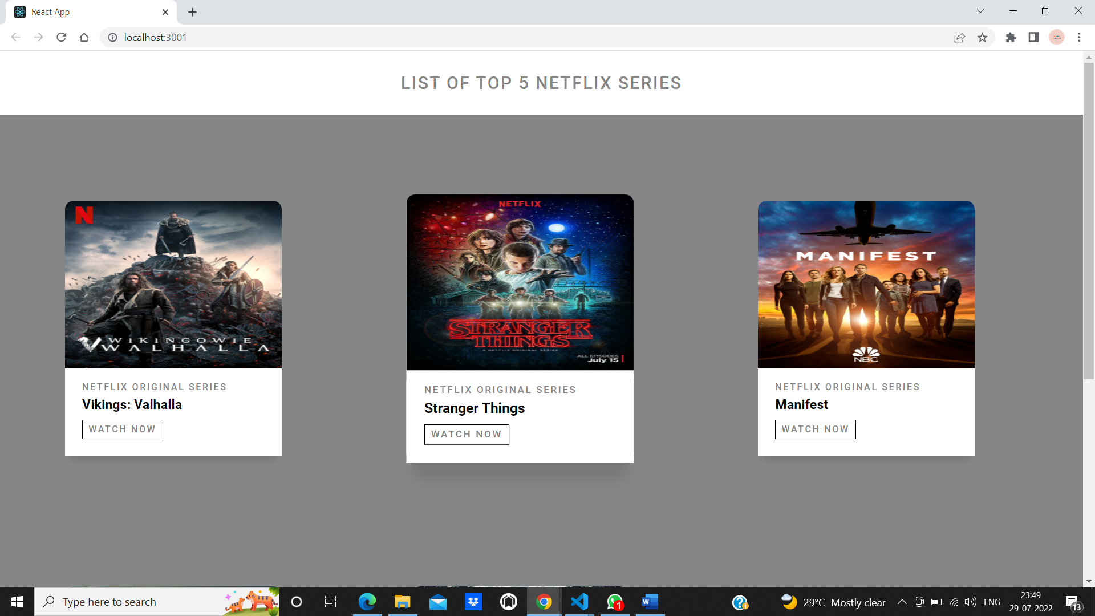

Fig 4.1 Netflix web app

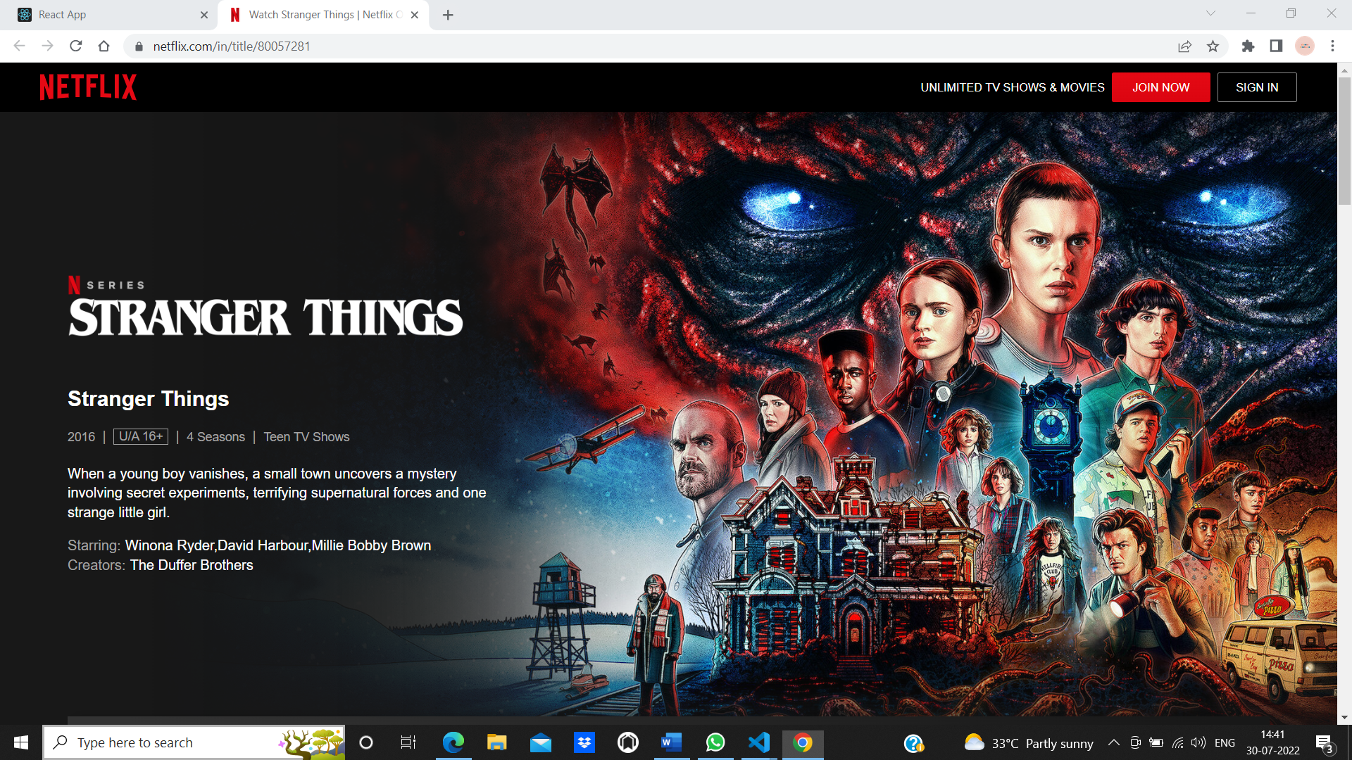

Fig 4.2 Netflix page

#### Web application for Digital Clock

#### Digital clock is created with the help of useState , date method and setInterval method.

#### The React useState Hook allows us to track state in a function component. It accepts an initial state and returns two values i.e the current state and a function that updates the state.

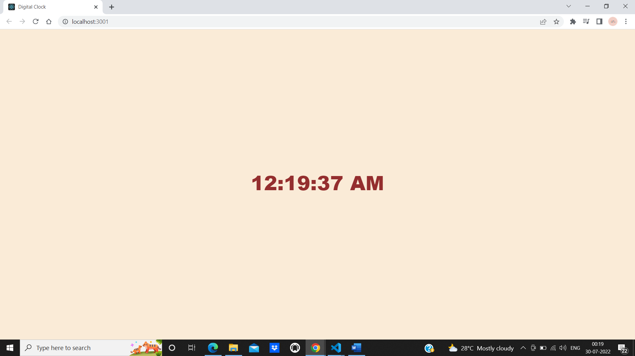

Fig 4.3 Digital clock

#### Web application for To Do List

#### Web application for to do list can be made using React Hooks.

#### The React useState Hook allows us to track state in a function component. It accepts an initial state and returns two values i.e the current state and a function that updates the state.

#### One can add and delete data from the list. For this along with hooks concept, map function, callback concepts are also used.

#### 

#### Fig 4.4 To Do List

## CHAPTER 5: WORKING WITH REACT PROJECT

* Using React many web applications can be made. This project is a social media app called “REACH ME”.
* It is made up of different components: Topbar, Sidebar, Feed(share and post), Rightbar.
* This project also covers profile, login and registration pages.

#### CREATED A TOPBAR COMPONENT:

#### Topbar component of website is styled using CSS and it is divided into different divs: the left div has logo, center div has searchbar and right div has some links notification icons and profile picture.

#### 

#### Fig 5.1 Topbar Component

#### 5.2 CREATED A SIDEBAR COMPONENT

#### Sidebar component consists of various icons which are taken from material-ui icons. It also displays friend list with profile picture and username.

#### Fig 5.2 Sidebar Component

#### 5.3 CREATED A SHARE COMPONENT

#### Share component consists of different icons and button and profile picture which is used to share different types of data like posts, Feed.jsx file consists of share and post components.

#### 

#### Fig 5.3 Share Component

#### CREATED A POST COMPONENT

#### It is included in feed.jsx file, to display multiple post, username, time dummydata.jsx file is used and like functionality is also implemented. Using map method, filter method, Hooks etc.

#### 

#### Fig 5.4 Post Component

#### CREATED A RIGHTBAR COMPONENT

#### Rightbar component has list of active users and has advertisements part.

#### 

#### Fig 5.5 Rightbar Component

#### CREATED A PROFILE PAGE

#### Profile page is user’s profile of web application. It consists of cover picture and profile picture and profile details, and also displays suggested user’s list

#### 

#### Fig 5.6 Profile page

#### CREATED A LOGIN PAGE.

#### 

#### Fig 5.7 Login page

#### CREATED A REGISTER PAGE

## 

#### Fig 5.8 Registration page

## CHAPTER 6: CONCLUSION

Learning “ReactJS” is fun and makes sense as it is providing much-needed ease to developers in building highly engaging web applications and user interfaces in a very lesser time, where they create large-scale apps with frequently changing data. React’s benefits of being robust, advanced, responsive,non-risky, user-friendly far exceed its disadvantages, and developers and organizations understand React’s relevance in the market

## REFERENCES

#### https://nodejs.org/en/download/

#### https://reactjs.org/

#### https://mui.com/material-ui/material-icons/

#### https://fonts.google.com/

#### <https://www.geeksforgeeks.org/how-to-create-a-responsive-sidebar-with-dropdown-menu-in-reactjs/>

#### <https://unsplash.com/s/photos/person>

#### https://unsplash.com/s/photos/theme